

#80000427-001
Firmware Auto Test Software
Specification
Rev.54
Revised: 05/17/2016

APPROVAL:
VP of Engineer: ________________________ Date: _______
Executive VP: ________________________ Date: _______

THIS DOCUMENT IS THE PROPERTY OF AND PROPRIETARY TO ID TECHNOLOGIES, INC. ITS USE IS AUTHORIZED ONLY FOR RESPONDING TO A REQUEST FOR QUOTATION OR FOR THE PERFORMANCE OF WORK FOR ID TECHNOLOGIES, INC.

ID TECH
10721 Walker Street, Cypress, CA90630 Voice: (714) 761-6368 Fax: (714) 761-8880
© 2016 ID Technologies, Inc. All rights reserved
Modification History
Rev | Date | Description of Changes | By
50 | 2015-10-30 | Draft | Borg
51 | 2015-12-18 | Appendix 1 - pseudo command add 3 commands for PCI Mac checkout function: 35. SET_DATE_NOW_MAC  36. MACCMDL1  37. MACCMDL2  38 SWIPEBUFMODE  39 CRGETUID  40 GETNONCE  41 GETDUKPTKSN  42 DMACCMDL100  Details please check: Appendix 1 - pseudo command set | Borg
52 | 2016-1-15 | 43 SWIPEKB:  44 LOAD_NEWCHECKVALUE:  45 LOAD_BOOTLOADCHECKVALUE:  46. ACM:  Details please check: Appendix 1 - pseudo command set | Borg
53 | 2016-3-01 | Add support ViVOpay HID Communication  Protocol support ViVopay protocol1 & ViVopay protocol2  Update:  33 ProSwitch  Add:  47 SETUID:  48 MACMED:  49 MACMEDEMV：  50 ATCMED  51 ATFILE  52 KeyLifePro  Appendix 6 – MACed for Spectrum Pro exp. | Borg
54 | 2016-5-17 | Update add support Spectrum Pro Decryption and 63 FID commands.  53 “SWIPEPRO:”  54 “MAC63PRO:”  55 “TTK_SELF_TEST:”  56 “LOAD_CERT:”  57 “LOAD_TAMPERHEADCV:” | Borg

TABLE OF CONTENTS
TABLE OF CONTENTS 3
1 Introduction 4
1.1 Purpose 4
1.2 Acronyms, Terms and Definitions 4
1.3 Target 4
2 Design Considerations 5
1.1 Assumptions 5
2.2 Constraints 5
2.3 System Environment 6
2.4 Risks and Volatile Areas 6
2.5 Compatible 6
2.6 Performance 6
3 Architecture 7
3.2 Overview 7
3.2 Subsystem or Component 7
3.2.1 UI layer 7
3.2.2 Test layer 8
3.2.3 Configuration layer 15
3.2.4 Communication layer 16
4 User interface design ( GUI ) 17
4.1 Main UI 17
4.2 Load Key UI 17
5 How to write script 18
5.1 Naming rules 18
5.1.1 Case Name: 18
5.1.2 Script Name 19
5.2 Commands sequence 19
5.3 Sample script 20
5.3.1 Script Eg.1 FW.B.001.01-02 20
5.3.2 Script Eg.2 FW.D.027.01-07 20
Appendix 1 - pseudo command set 24
Appendix 2 - about connect 27
Appendix 3 - how to test (Manual Command). 28
Appendix 4 - how to test (Automate Test). 30
Appendix 5 - auxiliary tool. 32
Appendix 6 – MACed for Spectrum Pro exp. 33
Appendix 7 – Update support ViVOpay HID protocol. 36

1 Introduction

1.1 Purpose
This document is meant to help technical teams (development test group) to implement firmware automated testing using Firmware Auto Test platform. Firmware Auto Test software (FAT) provides a framework to better combination of ID TECH products firmware protocol, communication interface, using simple pseudo code can quickly implement firmware test automation products, as well as the simple manual testing and generating detailed test record.
Through the unified management modular test cases and scripts, can realize quick deployment of new project test, improve test efficiency.

1.2 Acronyms, Terms and Definitions
Not all of the acronyms in this table are used in this document.
DVT | Design Verification Testing
API | Application Programming Interface
CPU | Central Processing Unit
DES | Data Encryption Standard
DUKPT | Derived Unique Key Per Transaction, Key management
TDES | Triple Data Encryption Standard
AES | Advanced Encryption Standard
CheckLrc | Check character to xor data
CheckSum | Check character to sum data
ETX | End of Text
EXP | Expiration Date
MSR | Magnetic Stripe Read
PAN | Primary Account Number
STX | Start of Text
FAT | Firmware Auto Test Software

1.3 Target
Phase 1
Complete the structure and basic functions of FAT platform.
Protocol: None Protocol;
ID TECH NGA Protocol;
ITP Protocol;
Interface: USB HID 8Bytes (ID TECH US HID Communication),
USB HID 64Bytes (ID TECH SH USB HID Communication) and
RS232 interface.

Object:
Unattended Auto-Testing percent: 75% above
Save time: Save 50% or above

Basis function:
- Manual Commands
- Analysis Perform Scripts
- Generate Report and Logs
- Some cryptogram

Platform:
Microsoft Windows XP or above.

Phase 2
Add additional function if needed.
Improve the Auto-test Efficiency.

2 Design Considerations

Assumptions
Test FAT is automated by running the scripts. Witch, also support manual testing capabilities (send and receive commands, card swipe, key injection and decryption...). FAT to read the script of the information ( command data, expected return data, artificial judgment info, prompt information and some definitions of pseudo code), run the script depending on the order of script design and execute it. By comparing the return value and the operator prompts judgment method such as judgment test results, and produces the test records, the log file.
FAT support once running single test script, and patch test scripts.

Constraints
- Automated Test scripts cannot cover all the test range, need to write the Test Case illustrates some manual testing as supplement.
- Some complex operations require special pseudo code calls the existing external executable program testing.
- The test case and test script must be design based on the firmware Design Spec, as well as the PRD.
- The test execution needs to be sorted out test records.
- The test script suffix must be ". txt ".
- The firmware get the firmware version command shall be limited to:
ITP protocol unit: 52 22.
NGA protocol unit: 78 46 01.
- Manual testing and test automation must connect at first.
- Script named must be based on the test case number.

System Environment
OS: Microsoft Windows XP, Win7, Win8, Win 10.
Protocol: NGA, ITP….
Interface: RS232, USB HID 8 bytes, USB HID 64 bytes communication.
Documents: Test Case, firmware design specification.
Input: Test script - *.txt.
Output: Test log file - *.Slg.
Language: VC++ 6.0.

Risks and Volatile Areas
- Does not support script debugging.
- Does not support script editor, according to the text editor.
- The consistency of each project the IDTECH firmware is not high.
- Script version management must be synchronous with the firmware change.

Compatible
Different projects the same function module can reuse test cases and test scripts, shorten the testing time.

2.6 Performance
- To shorten the test cycle:
Project | Manual Test | Automate Test
Intuit III | 3 days | 1 day
MiniSmart II | 3 days | 1 day
SPI Secure Head | 4 days | 1 day
UniPay | 3 days | 1 day

- Automation coverage about % 75.
- Test operator does not need to be familiar with the firmware, eliminate DVT test preparation time.
- Scripts management according to the function module management, strong reusability from project to project.
- Expansibility: complex function, can add the pseudo code test, with the new testing tools.

Architecture

Overview
FAT architecture consists of 5 layers: UI, Test, Configuration, Communication and Device.
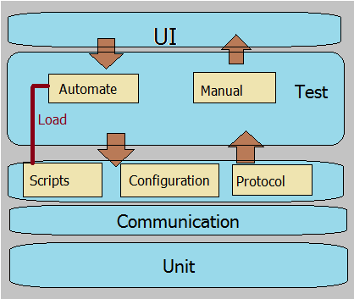
3.1-1

3.2 Subsystem or Component

3.2.1 UI layer
FAT UI support two test method: manual test, automate test.
- Manual test:
Manual testing supplement automated testing, and improve the firmware test coverage. Manual test provides basic functions:
- Send Command: Manual send command to device and receive response data.
- Enable MSR: Enable MSR card swipe, and automate decryption ID TEDH Output Format for Swipe and key in data Format.
- Load Key (Silk 2.0): Manual injection Sick 2.0 protocol DUKPT key.
- Load HSM KEK: Injection KEK key.
- Load TR31 B Keys: HSM TR31B format keys injection.
- Automate Test:
Automate Test contain 3 test types and 2 load cases methods:
Load cases method:
- Load single script: Import a single test script file.
- Load test library: Import the test script set path.
Test type:
- Single script test: Run the specified script, complete the following steps:
Load single script->Start Script->Stop Script->Clear Test.
- Test script set selective test:
Load test library->Select script from scripts list->Start single->Stop single.
- Test script set batch test:
Load test library->Auto Library-> Stop Library.
Note: Auto Library – Sequential run script library’s scripts.

3.2.2 Test layer
Test layer contain 2 test model: manual test, automate test.
Note: any test process should be done after unit connects successfully.

3.2.2.1 Manual test
Manual Test
Send command and get response data.
Enable MSR, get card swipe data and decrypt it.
Load HSM KEK
Load DUKPT Silk 2.0 protocol (MSR, ICC, Admin)
Load TR31B format keys …
3.2.2-1

a. Send command and get response:
Note. Send command only support input hexadecimal format data. Once send enable max 7 times read response, otherwise read response timeout.
Flow chart:
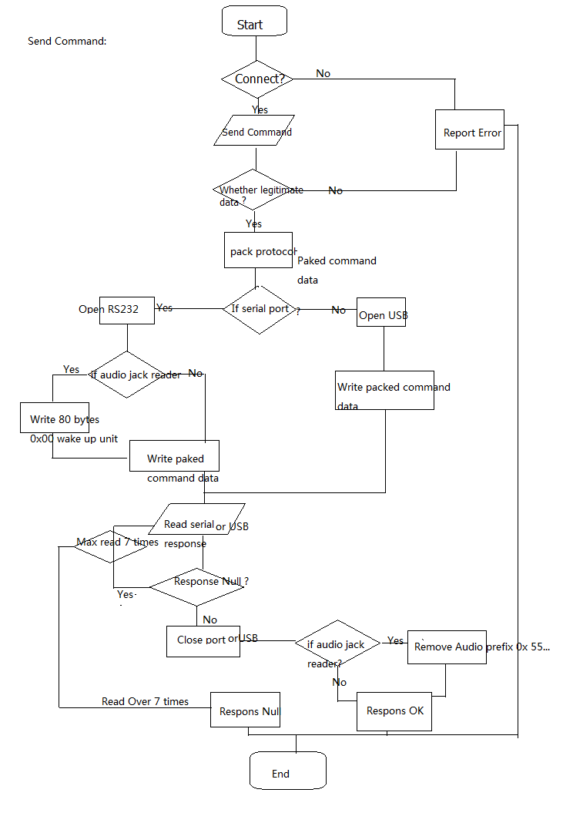
3.2.2-2

- Enable MSR:
Flow chart:

Note1: for some readers need to send enable MSR command before read card.
Example: Intuit III, UniPay – enable MSR command 73 46 51 30.
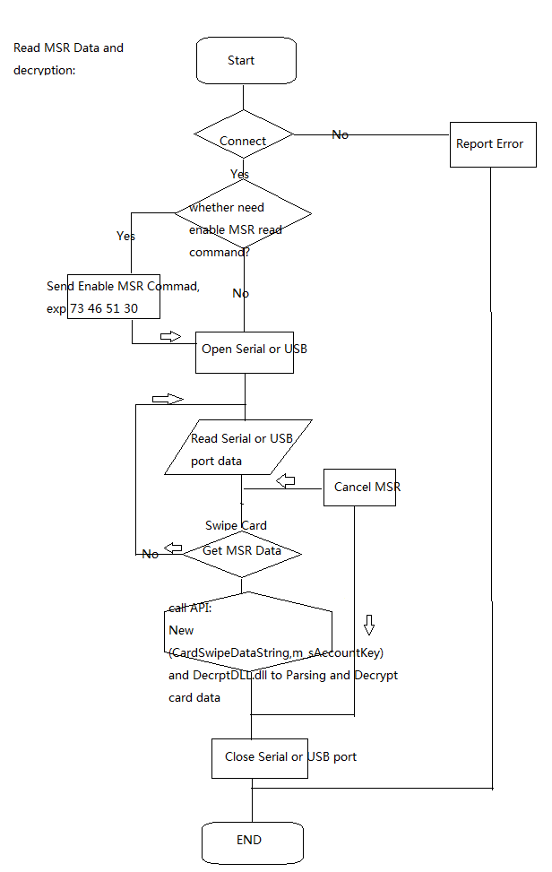3.2.2-3

Note2: Get MSR Card data software call API BOOL New(CString SCardData, CString GetKey) to analytic data.

Note3: DUKPT or Fix key encryption data decryption, the Firmware Auto Test calls the dynamic link library: DecryptDLL.dll.

- Manual key injection
FAT support manual key injection: Load Sick 2.0 protocol DUKPT key, Load HSM KEK and Load TR31 B Keys.
Note1: Key injection involving complex algorithm, call an external class APIs.
(DecryptDLL.dll, OpenSSL).
Flow chart:
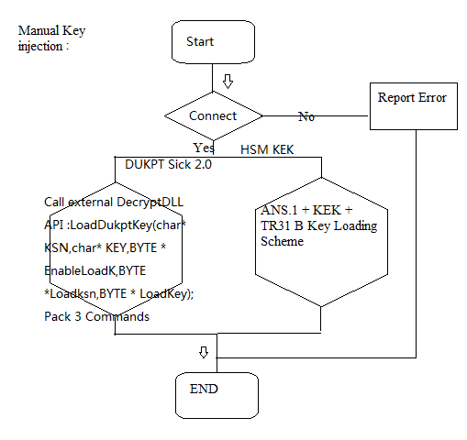
3.2.2-4
Note2: Example for DUKPT Silk 2.0 Key injection need to input 8 bytes KSN and 16 bytes DUKPT Key.
8 bytes KSN Data:
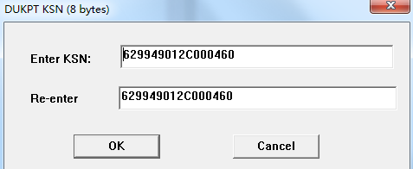
16 Bytes DUKPT Key:
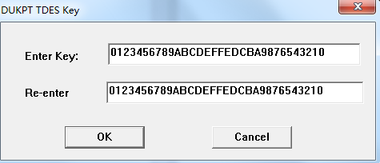
Note3: Load TR31B Keys defined some parameters setting as flows picture:
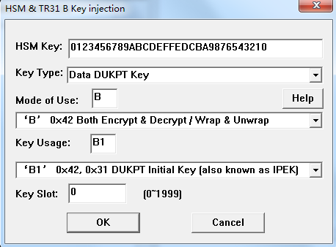

3.2.2.2 Automate test
Automate Test
Load Single Script
Load test library
Single script test
Test script set selective test
Test script set batch test
3.2.2-5

FAT automated test implementation depend on the script.
Test automation operation three elements:
No. | Name | Description
1 | Test Script | Test input file. Test designers writing scripts according to the firmware design spec and design test case document, each script contains one or more test cases, each case contains one or more pseudo code (custom commands) and the some description. Script file suffix name * .txt, compiled by the text editor.
2 | Automate Tool | The carrier of executing scripts.
3 | Test Log | Test output file. Named same as test script, suffix name * .Slg. Contain: Test result “Pass Test” or “Fail Test”, Issue Count “[Issue Count: x]”, Issue items the line number and name, detail test process data and point the conflict error description.
There are two ways to catch mistakes:
- Compare the expected return.
Based on the pseudo code in the script:
EXR | Expect response | EXR: <Complete or partial expect response body >
- Message report artificial judgment.
Based on the pseudo code in the script:
MESSAGECK | Artificial judgment | MESSAGECK: < Any message for confirm >
Automate Test Flow chart:
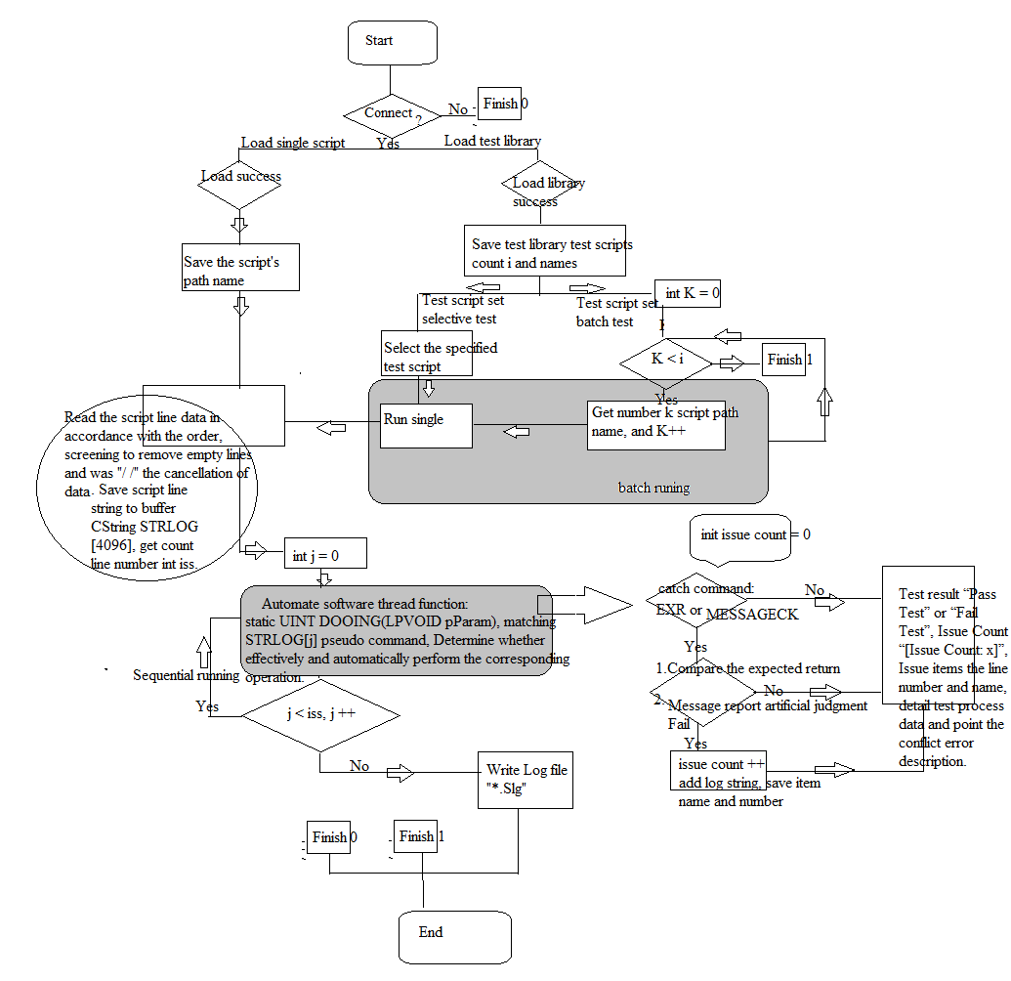
3.2.2-6
Note1: Automated test script defining pseudo command set reference appendix table 1.

3.2.3 Configuration layer
Test layer contain 3 parts: script, configure, protocol.
- Script: the test configure for automate test, details please refer to chapter 5.
- Configure: device software communication and some special settings for FAT test.
The operator must be configured bellow before testing:
  - Select interface: RS232, USB SH (HID 64 bytes), USB US (HID 8 bytes).
  - Set RS232 communication parameters: Com, Baud, Parity, Data Bits, Stop Bits.
  - USB HID communication parameters: PID, VID.
  - For the audio jack reader need set wake up setting.
Note: Phone jack wake up: send 80 bytes 0x00 before command body, order to wake up unit.
  - Setting commands interval, default (200ms).
  - Setting Account key for decryption.
- Protocol: FAT, enable 3 protocol option.
- NGA Protocol:
<STX><Length L><Length H> [Command Body] <CheckSum><LRC><ETX>
- ITP Protocol:
<STX> [Command Body]<ETX><LRC>
- NONE Protocol:
< Command Body>
Note1: The protocol configure apply to Manual Test “Send Command” and Automate Test Script command “CMD”.

3.2.4 Communication layer
FAT called “USB.h” and "serialconn.h" to achieve the bottom layer of a serial port and USB communication, encapsulate the API (CommandString, CommandHex) implementation command to send and receive operation:
BOOL CommandString(byte format,CString cmd,);
BOOL CommandHex(byte format,unsigned char * cmd,int len);
Note1: Parameter: byte format – Protocol
#define INTPackNGA 0x01
#define INTPackMSR 0x00
#define INTPackNONE 0x02
Note2: Reference flow chart 3.2.2-2.

4 User interface design ( GUI )

4.1 Main UI
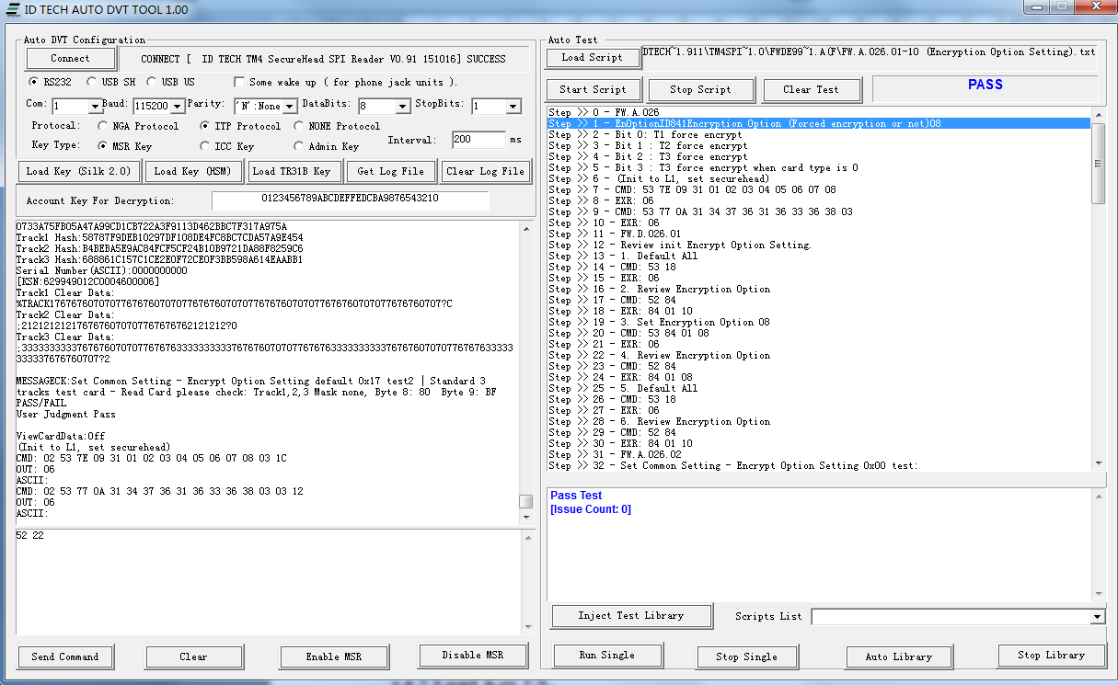

4.2 Load Key UI
Note: Message view UI is for shows detail MSR analytical and decrypt data. Witch only be triggered after script pseudo code “ViewCardData:On” and disabled by “ViewCardData:Off”.
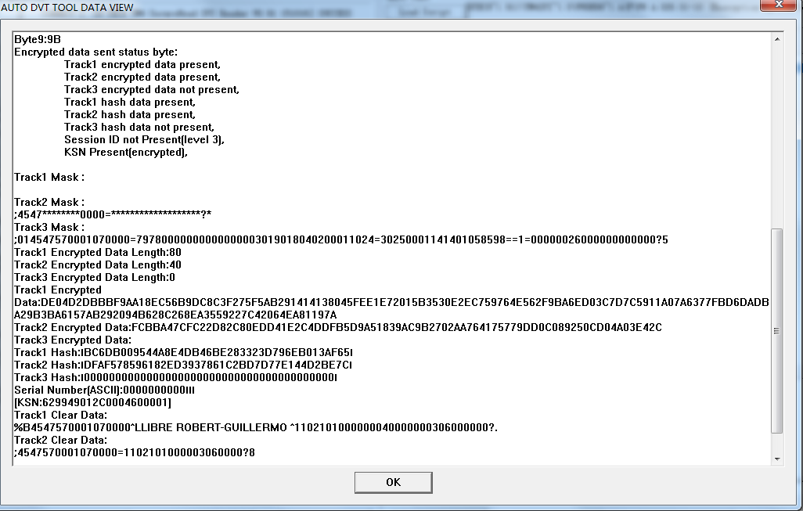

How to write script
Test designers writing scripts according to the firmware design spec and design test case document, each script contains one or more test cases, each case contains one or more pseudo code (custom commands) and the some description. Script file suffix name * .txt, compiled by the text editor.
Automated test script defining pseudo command set reference appendix table 1.

Naming rules
Script named must be based on the test case number.

Case Name:
Defined Test Case identifier : Category index.Content index.Feature Number.Case Number.

- Category Index:
Firmware Test - FW.
Stress/ Load Test - SL.
- Content index: According to the test content arrangement letter from A - Z.
- Feature Number: According to the test Feature arrangement index number 001 - 100.
- Case Number: Test case number for each test feature 1 - n.

Example | Test case identifier: FW.B.001.01
 | FW: Firmware Testing
 | B: General Grpup Task
 | 001: Get Firmware Release Version
 | 01: Get Device Firmware Version.

Example | Test case identifier: FW.B.001.02
 | FW: Firmware Testing
 | B: General Grpup Task
 | 001: Get Firmware Release Version
 | 02: Get bootloader version (Get device firmware version in bootloader mode).

Script Name
Each script contains one or more test cases.
Defined script Name: Category index.Content index.Feature Number.01-n.txt
Example: FW.B.001.01-02.txt

5.2 Commands sequence
The writing of the script can be according to certain sequence, make the test more reasonable.
Example:
Line 0 Case #
LOOP:
Line 2 MESSAGE:
Line 3 # Description
Line 4 CMD: or RCM:
Line 5 EXR:
Line 6 MESSAGECK:
LOOPEND:
…
Line n: …

Sample script

Script Eg.1 FW.B.001.01-02
Script File Name: FW.B.001.01-02 (Get Firmware Release Version).txt
NGA Protocol.
Content:
ID: FW.B.001-02
START
**********************************************

Get Firmware Release Version (NGA).
Command Body is 78 46 01
Response Body is 06 & some bytes Ascii codes.
**********************************************

FW.B.001.01
1. Get Device Firmware Version.
CMD: 78 46 01
EXR: 06
Note: Response Body is 06 & some bytes Ascii codes.
**********************************************
FW.B.001.02
Get bootloader version (Get device firmware version in bootloader mode).
2. Enter in bootloader mode.
CMD: 78 46 7A 49 52 46 57 00 00 00 00 00 00 00 00
EXR: 06
PROCESS:1
3. Get bootloader firmware version.
CMD: 78 46 01
EXR: 06
Note: reposne 02 1A 00 06 <"Bootloader FW ”> <PCI Indicator Flag> <“ Vx.yy " > <Block Num> <Package Num> <n> Lrc Sum 03
**********************************************
END

Script Eg.2 FW.D.027.01-07
FW.D.027.01-07 (Masked Clear Data Sending Option).txt
ITP Protocol.
Content:
FW.D.027.01-07
START
**********************************************
Masked clear data sending option

MaskOptID 86 1 Masked / clear data sending option 0x07
Bit0: T1 mask allowed
Bit1: T2 mask allowed
Bit2: T3 mask allowed
(Init to L1, set securehead)
CMD: 53 7E 09 31 01 02 03 04 05 06 07 08
EXR: 06
CMD: 53 77 0A 31 34 37 36 31 36 33 36 38 03
EXR: 06

1. Default All
CMD: 53 18
EXR: 06
PROCESS:3

2. Set MSR Key injection mode.
CMD: 53 AB 01 30
EXR: 06

3. Load DUKPT Key
Load KSN:629949012C000460
Load Key:0123456789ABCDEFFEDCBA9876543210

Enter Key Loading:
RCM: 02 46 46 2F 78 4D 42 41 75 38 3D 0D 0A 03 6D
EXR: 06 02 46 46 2F 77 41 42 42 50 6F 3D 0D 0A 03 1F
Load KSN:
RCM: 02 46 46 2F 77 6F 52 4D 6A 59 79 4F 54 6B 30 4F 54 41 78 4D 6B 4D 77 4D 44 41 30 4E 6A 43 74 0D 0A 03 73
EXR: 06 02 46 46 2F 77 41 47 52 6A 45 32 51 54 52 44 6A 67 3D 0D 0A 03 36
Load Key:
RCM: 02 46 46 2F 77 6F 68 4D 7A 67 79 4D 30 4E 43 4D 44 4E 42 4D 45 52 44 4E 6A 42 43 4D 6A 64 42 51 55 52 44 4F 45 46 42 52 6A 63 35 51 30 55 32 52 55 52 42 37 41 3D 3D 0D 0A 03 28
EXR: 06 02 46 46 2F 77 41 47 52 54 42 42 51 55 4D 35 39 67 3D 0D 0A 03 43
PROCESS:3

4.Enhanced Card data Enable Serial Number .
CMD: 53 30 01 04
EXR: 06

ViewCardData:On
MESSAGE: PLease Check Card Data Mask Data state, and byte 8 & byte 9 value.

FW.D.027.01
5. Set Common Setting - Mask Option Setting 0x00.
CMD: 53 86 01 00
EXR: 06

6. Enable MSR Swipe Card:
Enable MSR Swipe Card:
SWIPE: Swipe 3 tracks Europ 4909 test card in 30 secs.
MESSAGECK:Set Common Setting - Mask Option Setting 0x00 test1 | Europ 4909 test card - Read Card please check: Track 1,2,3 mask none, Byte 8: 80 Byte 9: BF. PASS/FAIL

FW.D.027.02
Set Common Setting - Mask Option Setting 0x00 test 2:
5.Enable MSR Swipe Card:
SWIPE: Swipe 3 tracks Standard test card in 30 secs.
MESSAGECK:Set Common Setting - Mask Option Setting 0x00 test2 | 3 Tracks Standard test card - Read Card please check: Track 1,2,3 shows plaintext, Byte 8: 07 Byte 9: 00. PASS/FAIL

FW.D.027.03
Set Common Setting - Mask Option Setting 0x01 test1:
Steps:
6. Set Common Setting - Mask Option Setting 0x01:
CMD: 53 86 01 01
EXR:06
7.Enable MSR Swipe Card:
SWIPE: Swipe 3 tracks Europ 4909 test card in 30 secs.
MESSAGECK:Set Common Setting - Mask Option Setting 0x01 test1 | Europ 4909 test card - Read Card please check:Track 1 shows mask, Track 2,3 mask none, Byte 8: 81 Byte 9: BF. PASS/FAIL

FW.D.027.04
8.Set Common Setting - Mask Option Setting 0x01 test2
SWIPE: Swipe 3 tracks Standard test card in 30 secs.
MESSAGECK:Set Common Setting - Mask Option Setting 0x01 test2 | 3 Tracks Standard test card - Read Card please check: Track 1,2,3 shows plaintext, Byte 8: 07 Byte 9: 00. PASS/FAIL

FW.D.027.05
Set Common Setting - Mask Option Setting 0x07 test1
9. Set Common Setting - Mask Option Setting 0x07:
CMD: 53 86 01 07
EXR:06
10.Set Common Setting - Encrypt Option Setting default 0x08
CMD: 53 84 01 08
EXR:06
11. Enable MSR Swipe Card:
SWIPE: Swipe 3 tracks Europ 4909 test card in 30 secs.
MESSAGECK:Set Common Setting - Mask Option Setting 0x07 test1 | Europ 4909 test card - Read Card please check:Track 1,2 shows mask, Track 3 mask none, Byte 8: 83 Byte 9: BF. PASS/FAIL

FW.D.027.06
12.Set Common Setting - Mask Option Setting 0x07 test2:
SWIPE: Swipe 3 tracks Standard test card in 30 secs.
MESSAGECK:Set Common Setting - Mask Option Setting 0x07 test2 | 3 Tracks Standard test card - Read Card please check: Track 1,2,3 shows plaintext, Byte 8: 07 Byte 9: 00. PASS/FAIL

ViewCardData:Off
FW.D.027.07
Review inital MaskOptID .
13. Default all.
CMD: 53 18
EXR: 06
14. Review default MaskOptID.
CMD: 52 86
EXR: 86 01 07
(Init to L1, set securehead)
CMD: 53 7E 09 31 01 02 03 04 05 06 07 08
EXR: 06
CMD: 53 77 0A 31 34 37 36 31 36 33 36 38 03
EXR: 06
**********************************************
END

Appendix 1 - pseudo command set
No. | Command. | Description. | Format
1 | CMD | Send Command 1 | CMD: < non - encapsulation protocol command body (Hex) >
2 | RCM | Send Command 2 | RCM: < encapsulation protocol command body (Hex) >
3 | EXR | Expect response | EXR: <Complete or partial expect response body >
4 | // | Shielding | // <Any data >
5 | DOEXE | Execute external program | DOEXE: < Script executable program detail name, under the current path >
6 | ViewAudioPrefix:On | Enable view Audio jack unit response prefix | ViewAudioPrefix:On
7 | ViewAudioPrefix:Off | Disable view Audio jack unit response prefix | ViewAudioPrefix:Off
8 | ViewCardData:On | Enable view detail MSR Card Swipe data | ViewCardData:On Enable view detail MSR Card Swipe data message dialog.
9 | ViewCardData:Off | Disable view detail MSR Card Swipe data | ViewCardData:Off Disable view detail MSR Card Swipe data message dialog.
10 | KeyLifeTest | Special command for DUKPT Key life test | KeyLifeTest: <Key life test command> Key life check command:78 46 C8 <Key Name> <1 byte NC> <32 bytes Clear Data>  response 06<32 bytes encrypted data><10 bytes KSN>
11 | DATATEST | Large length and random command test | DATATEST: < Integer command max length >
12 | LOOP | Start loop | LOOP:< Integer loop times>
13 | LOOPEND | Loop end point | LOOPEND:
14 | SET_DATE_NOW | Set date time now | SET_DATE_NOW:  For china NGA PCI protocol command
15 | ACTIVE | Active device | ACTIVE:
16 | LOAD_PUBLIC_KEY | Load public key | LOAD_PUBLIC_KEY:
17 | LOAD_FIRMWARE_KEY | Load firmware key | LOAD_FIRMWARE_KEY:
18 | LOAD_NUMERIC_KEY | Load numeric key | LOAD_NUMERIC_KEY:
19 | LOAD_CHECKVALUE | Load check value | LOAD_CHECKVALUE:
20 | MESSAGE | Message box view | MESSAGE: < Any data >
21 | MESSAGECK | Artificial judgment | MESSAGECK: < Any message for confirm >
22 | PROCESS | Keep reading port or Sleep | PROCESS: < Integer wait time ( Seconds ) >
23 | SWIPE | Swipe MSR data and decrypt | SWIPE: < Card info Data, Card name or Card feature >
24 | AuthFixKey | Fix key authentication | AuthFixKey: <Unit original fix key>
25 | LoadFixKey | Inject new fix key | LoadFixKey: <Inject new fix key>
26 | ActAuthRplyL4 | Security Level 4 authentication | ActAuthRplyL4: <Dukpt Key>
27 | DeActRplyL4 | Security Level 4 De-act | DeActRplyL4: <Dukpt Key>
28 | SetSoftKSN | Set 8 bytes KSN data for Load X Key. Item 30~32. | SetSoftKSN: <8 Bytes hex string KSN>
29 | SetSoftKEY | Set 16 bytes Key data for Load X Key. Item 30~32. | SetSoftKEY: <16 Bytes hex string Key>
30 | LOAD_HSM_KEK | Load HSM Kek | LOAD_HSM_KEK:
31 | LOAD_TR31B_KEY | Load TR31B format Key. | LOAD_TR31B_KEY:
32 | LOAD_DUKPT_KEY | Load Sick 2.0 format DUKPT Key. | LOAD_DUKPT_KEY:
33 | ProSwitch | Modify software commands protocol | 0:NGA.  1:ITP.  2:None.  3:ViVOpay1  4:ViVOpay2
34 | PINCOMMAND | Special defined for L100 get function key, get PIN, get numeric key, get amount | PINCOMMAND: <Get PIN Command Body>
35 | SET_DATE_NOW_MAC | For PCI device set date time command, which contain Mac data check? | SET_DATE_NOW_MAC:
36 | MACCMDL1: | Mac Length = 1 ,0x1E Command Pack | MACCMDL1: <Command Body>
37 | MACCMDL2: | Mac Length = 2 , 0x1E 0x00 Command Pack | MACCMDL2: <Command Body>
38 | SWIPEBUFMODE | Buffer mode card read. | SWIPEBUFMODE : < Card info Data, Card name or Card feature >
39 | CRGETUID | Get PINPAD Unique identification number | CRGETUID:< CR gets PINPAD UID Command >
40 | GETNONCE | Gets Nonce | GETNONCE:< Gets Nonce Command >
41 | GETDUKPTKSN | Get DUKPT Key Current KSN | GETDUKPTKSN:< Get DUKPT Key Current KSN Command>
42 | DMACCMDL100 | DOMACSCU for L100 … Devices | DMACCMDL100:< DOMACSCU packed Command >
43 | SWIPEKB: | USB HIDKB，PS2 Reader Card Swipe. | SWIPEKB:<Card info>
44 | LOAD_NEWCHECKVALUE: | Load check value from *.fm | LOAD_NEWCHECKVALUE:
45 | LOAD_BOOTLOADCHECKVALUE: | Load boot load check value 1 and 2 from two Bootloader *.fm files (for new PCI Units) | LOAD_BOOTLOADCHECKVALUE:
46 | ACM： | Asynchronous communication， max for 10 seconds timeout. | ACM：<Commandbody>
47 | SETUID: | Set host UID (exp Pro units) | SETUID: <8 bytes UID>
48 | MACMED: | MACed for Pro | MACMED: <Command body>
49 | MACMEDEMV： | MACed for Pro (Function ID as 2 bytes length command) | MACMEDEMV： <Command body>
50 | ATCMED: | AT Command for Pro | ATCMED: <Command body>
51 | ATFILE | Choose get AT *.pm from file select or use default path. | true: for file selection  false: init path "CR_CertsFolder\\DMK.pem";
52 | KeyLifePro | Special command for SpectrumPro DUKPT Key life test | KeyLifePro : <Key life test command> Key life check command example:7646AC0C00010008003031323334353637
53 | SWIPEPRO: | Spectrum Pro MSR read and Decryption | SWIPEPRO: <Card Message>
54 | MAC63PRO | Spectrum Pro ICC 63 FID commands | MAC63PRO: <APDU + data Encryption Key>
55 | TTK_SELF_TEST: | Test Implement TTK’s Self-Test function | TTK_SELF_TEST:
56 | LOAD_CERT: | Load Certificate File Command (72 46 12 LenL LenH <Cert Data) | LOAD_CERT:
57 | LOAD_TAMPERHEADCV: | Load Empthy Tamper Head Check Value from *.fm | LOAD_TAMPERHEADCV:

Automated test script defining pseudo command set table:
Note: Some pseudo code is only for special equipment firmware. If there are new features will continue to update this table.

Appendix 2 - about connect
FAT must be connected devices before any operation.
The connect operation: will try to get device firmware version. If connection configuration is valid and apply to the connected devices. Click connect button Firmware Auto Test shows connect info:
Success: “CONNECT [firmware version] SUCCESS”,
Fail: “Connect fail”.
In view of the company products NGA and ITP protocol units defined difference get firmware version command:
ITP: 52 22
CommandString(INTPackMSR,"52 22",false).
NGA: 78 46 01
CommandString(INTPackNGA,"78 46 01",false).

Note: Connect operation will init “Account Key For Decryption” as m_sAccountKey = "0123456789ABCDEFFEDCBA9876543210", it’s use for card swipe data auto decryption, After the connection is successful can modify it according to actual situation.

Appendix 3 - how to test (Manual Command).
Example1: Secure Head Manual Get Firmware Version.
Test device TM4 SPI Secure Head.
Configure: | Setting
Interface: | RS232
Audio Jack: | None
Com: | 1
Baud: | 115200bps
Parity: | ‘N’
Data Bits: | 8
Stop Bits: | 1
Protocol: | ITP
Key Type: | None
Interval: | 200ms
Steps:
- Connect reader to test computer com1, and 5V power supply.
- Open FAT and set configuration settings and connect.
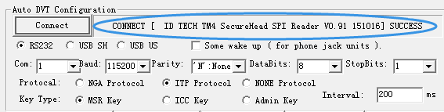
- Enter get firmware version command 52 22 and click “Send Command” button.
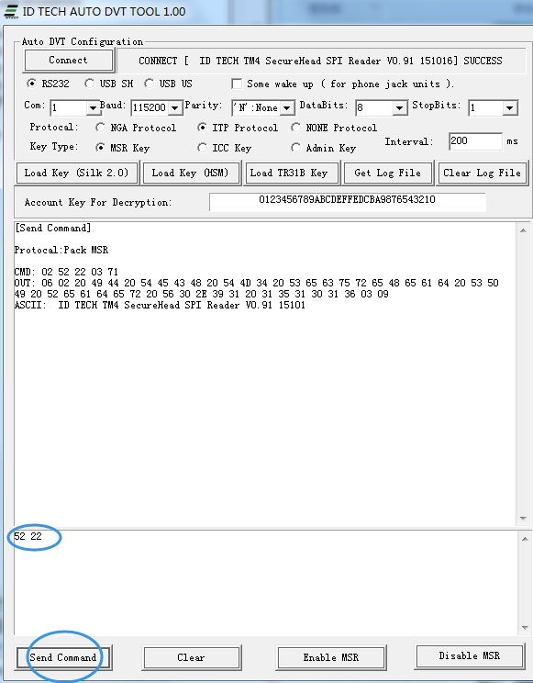

Appendix 4 - how to test (Automate Test).
Example1: Run Script FW.A.026.01-10 (Encryption Option Setting).txt
Test device TM4 SPI Secure Head.
Configure: | Setting
Interface: | RS232
Audio Jack: | None
Com: | 1
Baud: | 115200bps
Parity: | ‘N’
Data Bits: | 8
Stop Bits: | 1
Protocol: | ITP
Key Type: | None
Interval: | 200ms
Steps:
- Connect reader to test computer com:1, and 5V power supply.
- Open FAT and set configuration settings and connect.
- Click button load script choose script File: FW.A.026.01-10 (Encryption Option Setting).txt
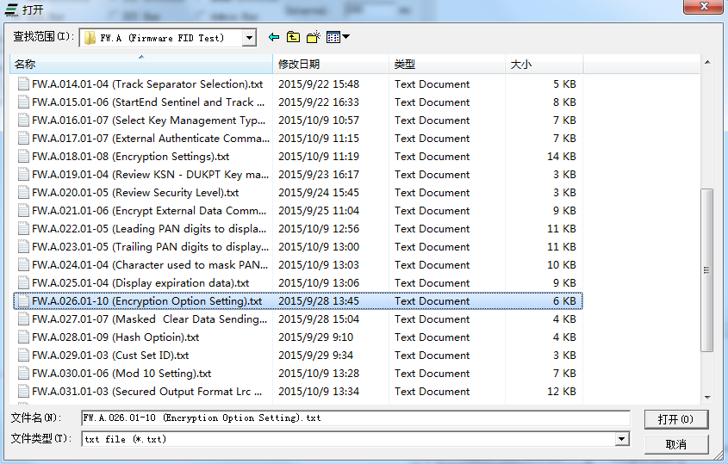
- Get script data to FAT.
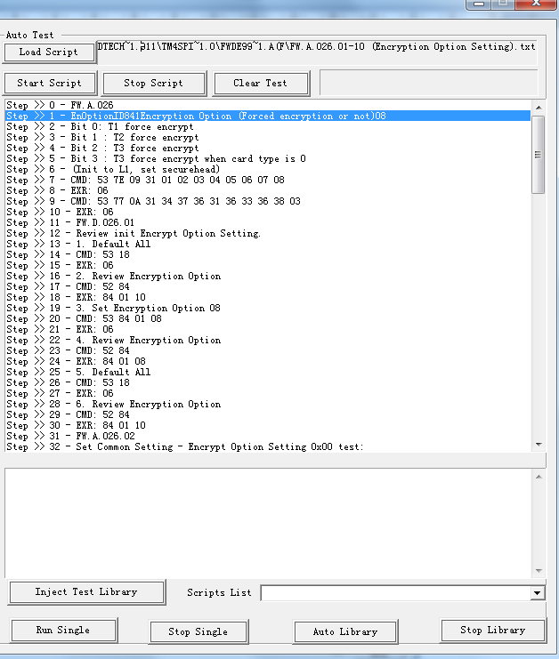
- Click button start script (Single Script Test).
- According to clew to complete the test (If need human intervention test, such as credit card, enter the PIN).
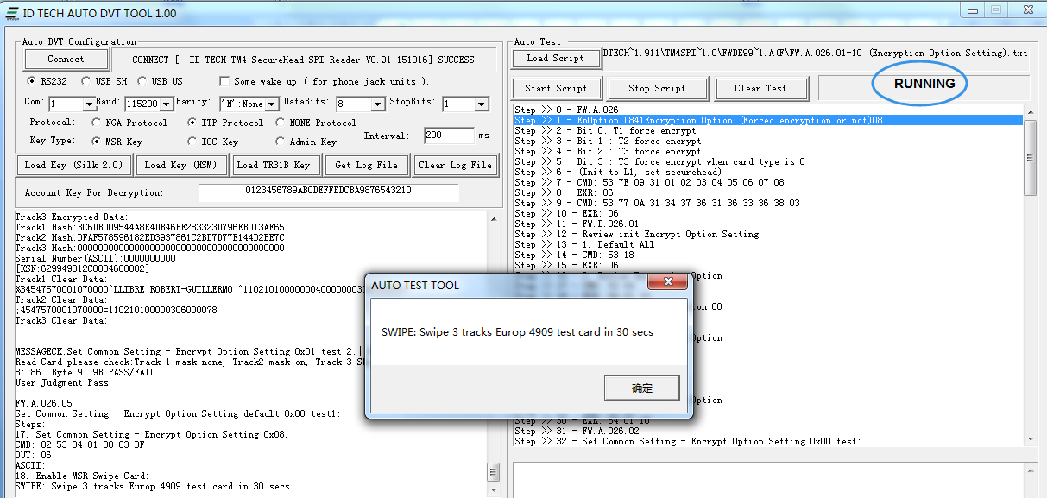
- Finish test.
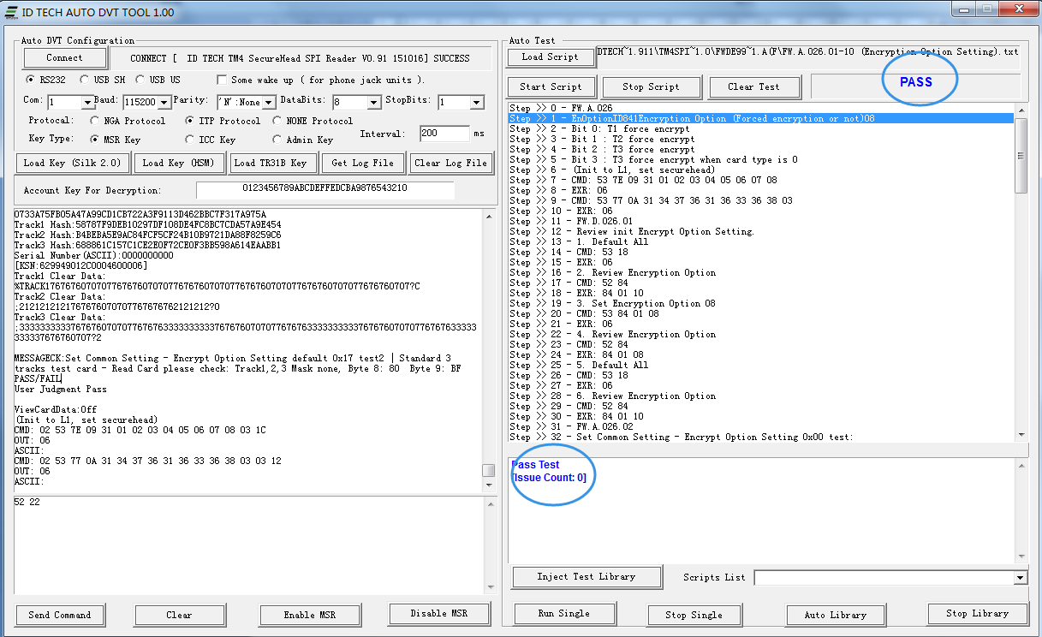
- After testing the script path automatically generated test Log file.
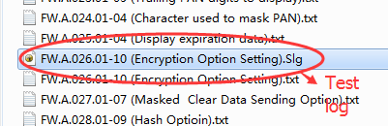

Appendix 5 - auxiliary tool.
Design the tools “Auto Test Result”, through the analysis of the Log file to convenient statistical test results.
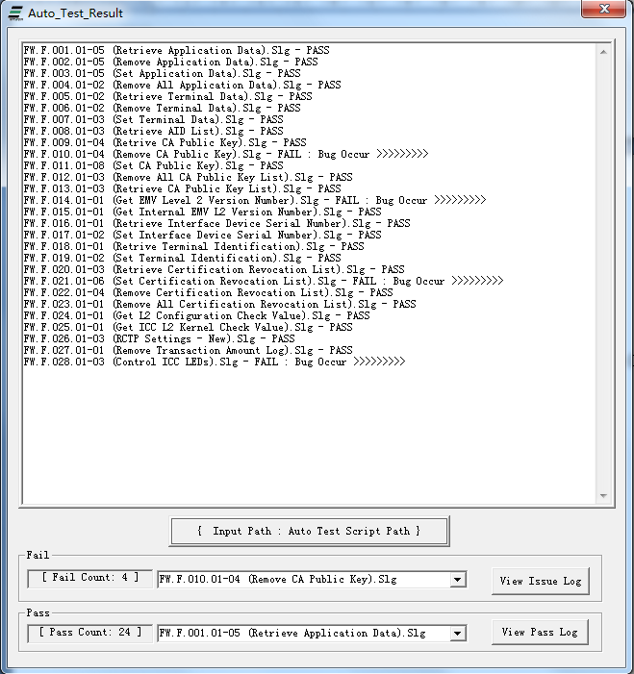
View Issue Log: View the failure log file data.
View Pass Log: View the success log file data.
Get the fail count and pass count.

Appendix 6 – MACed for Spectrum Pro exp.
45 – Activate and Deactivate Removal Sensor, MACed
SETUID:3100500019272E65
GETNONCE:76 46 27 12 00 10 00 11 22 33 44 55 66 77 88 99 00 11 22 33 44 55 66
GETDUKPTKSN:76 46 3E 01 00 05
MACMED:76 46 45 00 00 08 00 31 00 50 00 19 27 2E 65 01 00 00 02 00 3C 00
PROCESS:2
SETUID:3100500019272E65
GETNONCE:76 46 27 12 00 10 00 11 22 33 44 55 66 77 88 99 00 11 22 33 44 55 66
GETDUKPTKSN:76 46 3E 01 00 05
MACMED:76 46 45 00 00 08 00 31 00 50 00 19 27 2E 65 01 00 01 02 00 3C 00

Running Log:
>>[Do Scripts]>>
SETUID:3100500019272E65
User Set UID
UID:[3100500019272E65]
GETNONCE:76 46 27 12 00 10 00 11 22 33 44 55 66 77 88 99 00 11 22 33 44 55 66
CMD: 02 17 00 76 46 27 12 00 10 00 11 22 33 44 55 66 77 88 99 00 11 22 33 44 55 66 73 67 03
OUT: 02 18 00 06 67 46 27 12 00 10 00 15 1C 61 B0 5E 6F 73 95 99 97 37 29 E8 F6 1C F1 EE 8E 03
ASCII: gF' a癪os暀?)桷 ?
GETDUKPTKSN:76 46 3E 01 00 05
CMD: 02 06 00 76 46 3E 01 00 05 0A 00 03
OUT: 02 10 00 06 67 46 3E 0A 00 FF FF 27 5E A5 60 7F 40 00 01 91 43 03
ASCII: gF> '^@
MACMED:76 46 45 00 00 08 00 31 00 50 00 19 27 2E 65 01 00 00 02 00 3C 00
DO MAC SCU
DBKey:0123456789ABCDEFFEDCBA9876543210
KSN:FFFF275EA5607F400001
NONCE:151C61B05E6F739599973729E8F61CF1
UID:3100500019272E65
CMD: 02 34 00 76 46 45 2F 00 08 00 31 00 50 00 19 27 2E 65 01 00 00 02 00 3C 00 10 00 8E EB 15 85 FB DC BA 82 8A 01 01 65 3B E4 1F 14 0A 00 FF FF 27 5E A5 60 7F 40 00 01 30 96 03
OUT: 02 06 00 06 67 46 45 00 00 62 F8 03
ASCII: gFE
PROCESS:2
Response Null

SETUID:3100500019272E65
User Set UID
UID:[3100500019272E65]
GETNONCE:76 46 27 12 00 10 00 11 22 33 44 55 66 77 88 99 00 11 22 33 44 55 66
CMD: 02 17 00 76 46 27 12 00 10 00 11 22 33 44 55 66 77 88 99 00 11 22 33 44 55 66 73 67 03
OUT: 02 18 00 06 67 46 27 12 00 10 00 FA 82 90 32 A1 53 F4 4E 3B 40 02 D1 75 E4 3D 66 F2 BA 03
ASCII: gF' 鷤?鬘;@ 製?f
GETDUKPTKSN:76 46 3E 01 00 05
CMD: 02 06 00 76 46 3E 01 00 05 0A 00 03
OUT: 02 10 00 06 67 46 3E 0A 00 FF FF 27 5E A5 60 7F 40 00 01 91 43 03
ASCII: gF> '^@
MACMED:76 46 45 00 00 08 00 31 00 50 00 19 27 2E 65 01 00 01 02 00 3C 00
DO MAC SCU
DBKey:0123456789ABCDEFFEDCBA9876543210
KSN:FFFF275EA5607F400001
NONCE:FA829032A153F44E3B4002D175E43D66
UID:3100500019272E65
CMD: 02 34 00 76 46 45 2F 00 08 00 31 00 50 00 19 27 2E 65 01 00 01 02 00 3C 00 10 00 B0 1B CB 76 C7 BA C0 CE 7C 81 99 CC B5 73 63 C6 0A 00 FF FF 27 5E A5 60 7F 40 00 01 4E FC 03
OUT: 02 06 00 06 67 46 45 00 00 62 F8 03
ASCII: gFE

Appendix 7 – Update support ViVOpay HID protocol.
